 | Morning | Afternoon
Day 1 | Create your own board game to play with family members. | Learn the alphabet in British Sign Language:  https://www.british-sign.co.uk/fingerspelling-game/#  Can you spell your name? How many seconds did it take you?  Greetings:  https://www.youtube.com/watch?v=XigcNBFG1u4
Day 2 | Learn about your family history and create a family tree. | Plan and cook an evening meal (with adult supervision, of course) for your family – don’t forget to set the table and create your own restaurant style menu! Perhaps your family members can rate the experience based on presentation and taste.
Day 3 | Create an indoor/outdoor obstacle course for your family to take part in. | Research constellations – can you identify any well-known constellations in the evening?  https://www.ducksters.com/science/physics/constellations.php
Day 4 | Make a den in your back garden. Don’t forget to post photos on Google Classroom | DIY bowling – create makeshift bowling pins out of your recycling. Perhaps you could decorate your bowling pins too?
Day 5 | Explore the world using Google Earth – where have you been before? Where would you like to go? How far away are the places? How long would it take to walk or fly? | Plan and host a movie night with family. Arrange the room to your preferred style, choose the snacks and the film, and don’t forget to create the movie tickets to gain entry to the movies!
Day 6 | Bake cookies/biscuits/ cupcakes (make sure an adult supervises). | Shadow drawing - 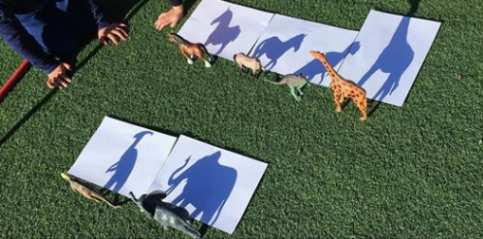
Day 7 | Craft: Learn a new skill. E.g. sewing, knitting, embroidery, skipping. | Research and memorise the Kings and Queens (UK).  https://www.youtube.com/watch?v=vC6okzIKQvg
Day 8 | Host a tournament e.g. seated volleyball (with balloons if inside), hula-hooping, penalty shoot-out. | Craft:  Finger painting https://www.youtube.com/watch?v=_Qe8MOhKaiM  If you don’t have paints, why not make sock puppets from old/odd socks?
Day 9 | Create your own family song – perhaps you’ll choose to include some musical instruments. | Set up a camp in your back garden (living room). Will you camp out overnight? Be sure to send a photo on Google Classroomof your set-up.
Day 10 | Make fruit kebabs (with adult supervision). | Indoor/outdoor garden tea party or picnic with family. Will it have a theme? Perhaps you’ll choose to dress up!

- Write an acrostic poem about Easter.
- Make a smoothie and write the instructions to go with it.
- Do a shape hunt in your house. How many triangles, squares and rectangles can you find?
- Do some coin rubbings with wax crayons.
- Write a book review about the book you are currently reading.
- Create your own set of top trump cards.
- Visit an online art gallery, create a picture in the style of your favourite artist.
- Design your dream classroom and build it out of Lego.
- Do a nature hunt. How many different types of trees / flowers do you have in your garden or can see from your window. What are they called? Sketch your favourite.
- Make an Easter theme word search or crossword.
- Practise your times tables whilst brushing your teeth.
- Write a comic strip called The Mystery of the Missing Easter Egg.
- Make a list of things you are grateful for and why.
- Write a letter to a neighbour, friend or family member.
- Create your own piece of dot art, you could use paint and the end of a brush or pencil, or you could draw dos with a felt tip or colouring pencil.
